Project Summary Aptech/North Nazimabad

E-Project Review Document

**09-Oct-2019**--- **08-Nov-2019**

16/oct/2019

Gracious Garments

Start End Date Of Project

Project

Report date

Problem Statement:

GRACIOUS GARMENTS is selling various types of GARMENTS for both MEN and

WOMEN. The company advertises by distributing the pamphlets, advertising on

television and so on. Due to rapid development in internet field, the company

decides to launch a website where people will get all the information about the

various products available with them easily.

Project Progress:

Pages

About

Home Page

Contact Us

Home Page :

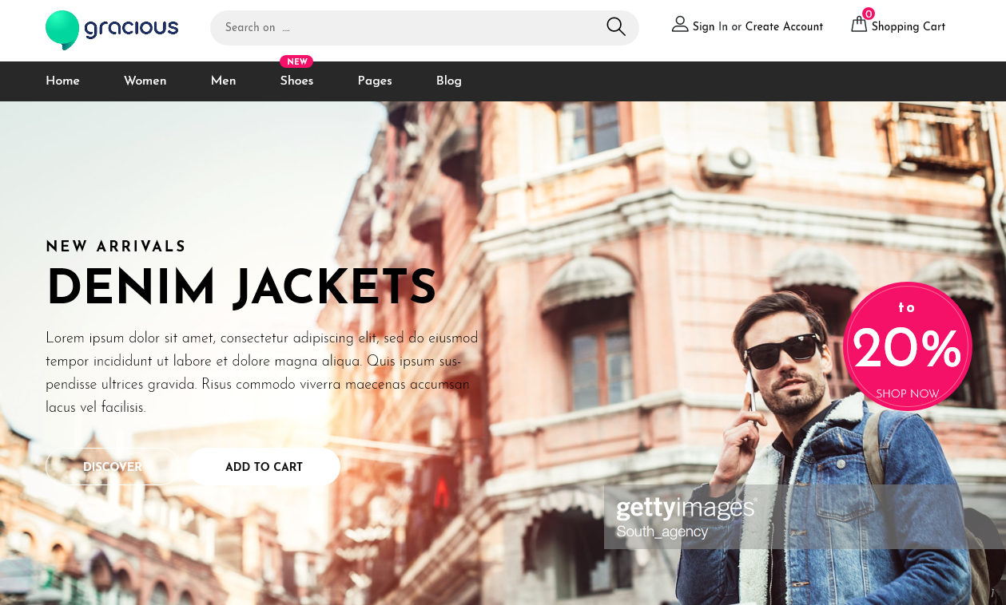

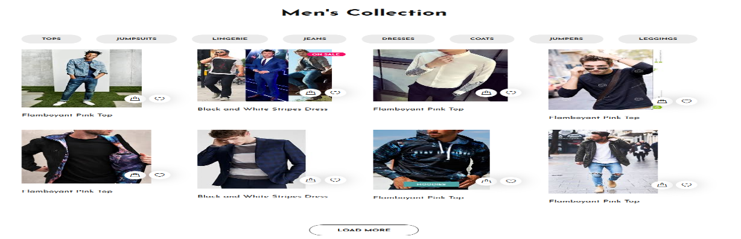



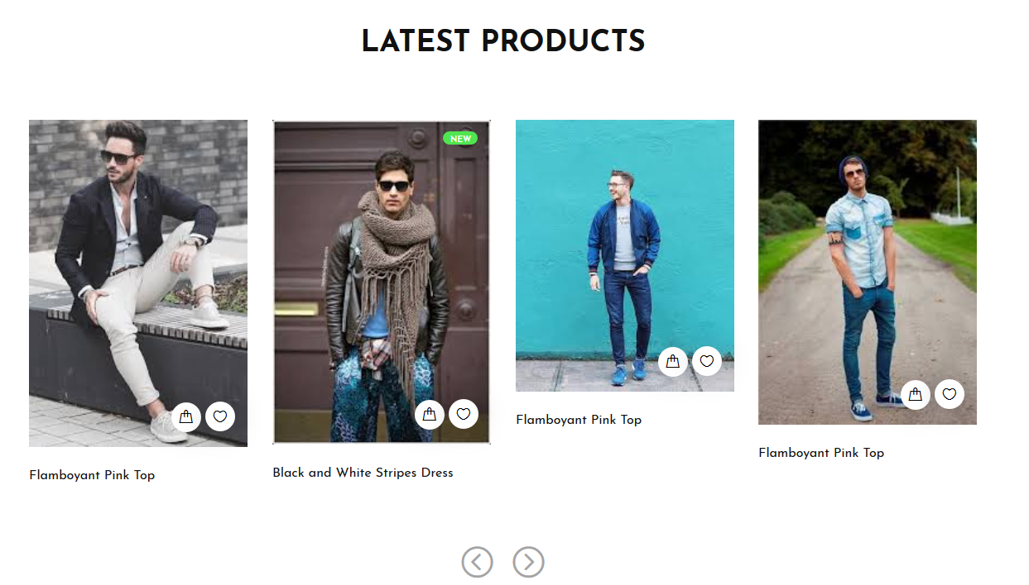

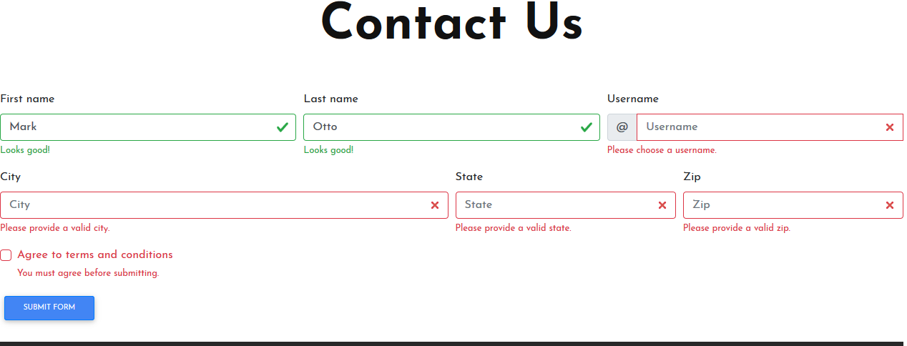 About Us:

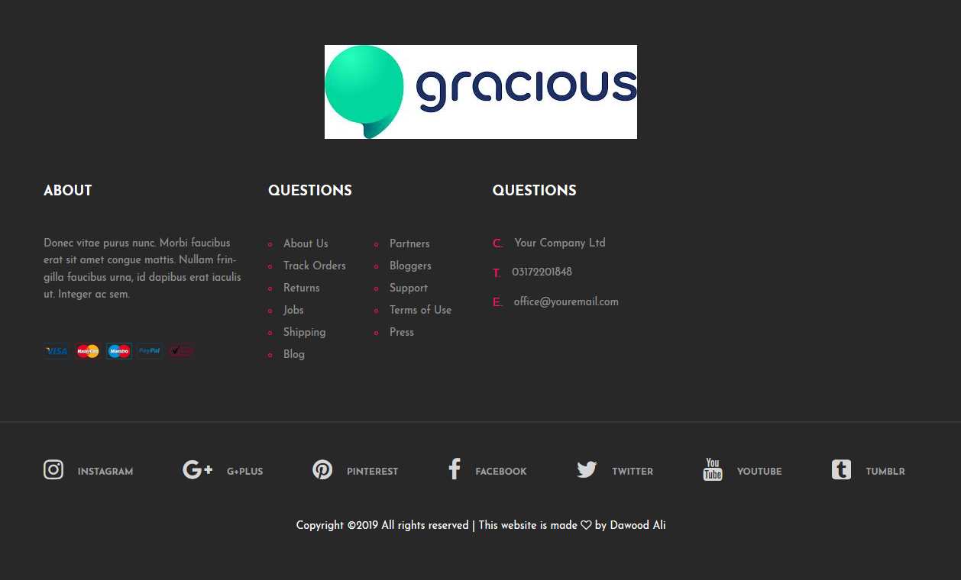

Group Member And Working:

|  |  |  |
| --- | --- | --- |
| Student Name | Enrollment # | Working |
| Dawood Ali | Student1206801 | Home page,Header, about,form,feedback form,Carousel,Blogs Section on home page,Men Section on home page, ,Footer |
| Taha naeem | Student1205772 | Men’s Collection,navbar,logo |
| Fahad jaweed | Student1206776 | - |
| Syed Ammar Ali | Student1204149 | - |